Plotting a Graph

1. Generate a table of number pairs :
t p(t)
0 30.0
1 27.1
2 22.6
… … (for t= 0,…, n-1)
Or
i x y
0 0.0 0.0
1 2.0 32.0
2 3.0 72.0
… … … (x, yfor i=0,…, n-1)
These numbers may represent experimental data,
say position p(t) vs. time t for a falling object or
may be generated from a particular functional relation between x and y as y(x)=8x

2. Determine the range of both xand y
A determination of both the minimum and maximum
values of x and y in the data set :

(Range)=(x - x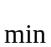)
(Range)= (y - y)

These values are then used for scaling the x and y axes.

That is, adjusting the scales of the axes so that the graph fits neatly on the graph paper.

3. Step through the points and graph them one by one.

| * Y |
| * |
X | * |
| * |
| * |
| * |
| * |

Note:
1.When one line is displayed, 80 or so characters will be printed for a particular value of x.
2. All of these characters will be blanks except one.
3. The position corresponding to y will contain some symbol --- e.g.,an asterisk.
4. To determine the proper placement of asterisk, consider the following:

y = 16.38 y= –7.21
so
(Range)= 16.38 – (–7.21) =23.59

Problem:
If at x= 3.0, y(3.0)=12.2,
where in the horizontal line is the asterisk to be printed?

If the y axis is to be 81 columns wide, we could first define

Ratio = 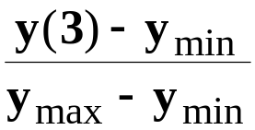

Notice that ratio is between 0.0 and 1.0.
The appropriate column(position) for the asterisk is

IY = ceil ( 80 * Ratio)

For the particular choice of numbers above , y(3) =12.2
We obtain:

Ratio = 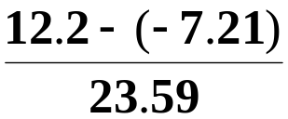 = 0.82281

IY =ceil( 80 * 0.82281) = ceil(65.8248) =66

Where double ceil(double x)
Return 大於x值的最小整數

